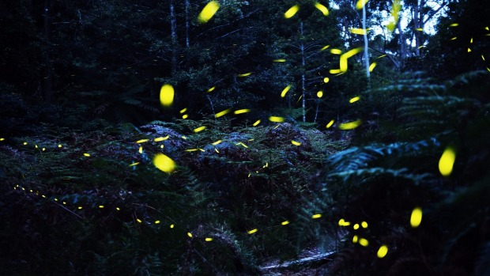
Magical: Fireflies blinking among Australian ferns in the early evening in a sheltered canyon west of Sydney. Photo: Nick Moir

